 | SAKR MANNING AGENCY  FOR RECRUITING EGYPTIAN LABOR ABROAD | Issue Date | 15.05.2022
 |  | Revision Date | 01.02.2024
 | Crewing Management Manual  Seafarer Employment Application | Revision | 1.3
 |  | Page | 4

Application For Position as | Third Engineer
Register Code. | ER-3.006
Other Position (If Any) | Fourth Engineer
Register Date | 19.09.2022
Last up Date Data | 28-08-2025
Expected Salary / Available Date | 1800 / Available immediately
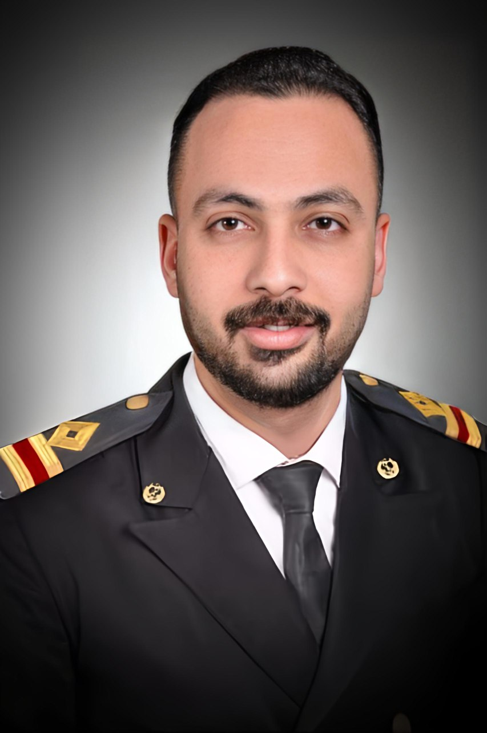

1. PERSONAL DETAILS
Full Name | KARIM ALI KASSEM ALLAM
Date Of Birth | 07-08-1997 |  |  |  |  |  | Marital Status |  |  |  |  |  | Single |  |  |  |  |  | Married
Nationality | Egyptian |  |  |  |  |  | Height (Cm) |  |  |  |  |  | 179 |  |  |  | Weight (Kg) |  |  |  |  | 74
Place Of Birth | Tanta |  |  |  |  |  | Overall Size |  |  |  |  |  | XL |  |  |  | Shirt Size |  |  |  |  | XL
Nearest Port | Alexandria |  |  |  |  |  | Trouser Size |  |  |  |  |  | 36 |  |  |  | Shoes Size |  |  |  |  | 44
2. EDUCATION
College / School | Technical Institute for Marine Facilities / Arab Academy for Science Technology & Maritime transport
Marline Test | Issued Date |  |  |  | Result % |  |  |  | Issued By (Authority) |  |  |  |  |  |  | Issued At
English Language | Fluent |  |  |  |  | Good |  |  |  |  |  | Average |  |  |  | Poor
……… Language  ( ) | Fluent |  |  |  |  | Good |  |  |  |  |  | Average |  |  |  | Poor
3. CONTACT DETAILS
Home Address / City | Ekhnaway / Tanta
E-Mail | Kareemqassem347@gmail.com |  |  |  |  |  | Mobile / Tel | +201013686146 |  |  |  |  |  |  |  |  |  | +201149346966

4. TRAVEL DOCUMENTS
Type | Document No. |  |  | ISS. Date |  |  | Exp. Date |  |  |  | ISS. By (Authority) |  |  |  |  |  |  |  | Place of Issue
Passport | A42572122 |  |  | 24-08-2025 |  |  | 23-08-2032 |  |  |  | Egyptian Authority |  |  |  |  |  |  |  | Tanta
Seaman Book | S00056177 |  |  | 11-08-2025 |  |  | 23-07-2030 |  |  |  | EAMS |  |  |  |  |  |  |  | Alex.
Other Seaman Book | CY367442 |  |  | 27-07-2023 |  |  | 26-07-2033 |  |  |  | Republic of cyprus |  |  |  |  |  |  |  | cyprus

5. PROFESSIONAL QUALIFICATION / CERTIFICATE OF COMPETENCY
Certificate Name |  |  | Number | Issue Date |  |  |  |  |  | Expiry Date |  |  |  | Issued By |  |  |  |  |  |  | Issued At
COC ( Rank) Third Engineer |  |  | 7197 | 07-08-2025 |  |  |  |  |  | - |  |  |  | EAMS |  |  |  |  |  |  | Alex.
GOC |  |  |  |  |  |  |  |  |  |  |  |  |  | NTRA |  |  |  |  |  |  | Cairo
6. NEXT OF KIN / EMERGENCY CONTACT
Full Name |  | Mohamed Ali Kassem Allam |  |  |  |  | Relationship |  |  |  |  | married
Address / Country |  | Egypt-Tanta
Tel. No./ Mobile |  | +201229327314 |  |  |  |  | Email |  |  |  |  | Mohamedqassem012345@gmail.com
7. HEALTH CERTIFICATES & VACCINATIONS
Flag State |  | Number |  |  | Issue Date |  |  |  |  | Expiry Date |  |  |  |  | Issued By |  |  |  |  | Issued At
International Medical |  | - |  |  | 17-08-2025 |  |  |  |  | 16-08-2027 |  |  |  |  | EAMS |  |  |  |  | Alex.
Yellow Fever |  | 9601 |  |  | 29-01-2020 |  |  |  |  | Forever |  |  |  |  | Ministry of Health |  |  |  |  | Egypt
Cholera |  | - |  |  | - |  |  |  |  | - |  |  |  |  | Ministry of Health |  |  |  |  | -
Covid-19 |  | Vaccination Name |  |  | First Dose |  |  |  |  | Second Dose |  |  |  |  | (Other Does or Remarks)
 |  | Pfizer |  |  | 01-01-2022 |  |  |  |  | 22-01-2022

8. MARINE COURSES
Course Name | Number | Issue Date | Expiry Date | Issued By / At
Personal Survival Techniques | 42120/19/EG | 28-11-2019 | 27-11-2024 | AASTMT / Alex
Proficiency In Personal Survival Techniques | 31015/25/EG | 29-07-2025 | 27-07-2030 | AASTMT / Alex
Fire Prevention and Fire Fighting | 42120/19/EG | 28-11-2019 | 27-11-2024 | AASTMT / Alex
Advanced Fire Prevention and Fire Fighting | 31236/25/EG | 29-07-2025 | 23-07-2030 | AASTMT / Alex
Elementary First Aid | 42120/19/EG | 28-11-2019 | 27-11-2024 | AASTMT / Alex
Medical Care Studies | 31181/25/EG | 29-07-2025 | 23-07-2030 | AASTMT / Alex
Personal Safety and Social Responsibilities | 32076/25//EG | 04-08-2025 | 30-07-2030 | AASTMT / Alex
Proficiency Of Security Awareness Training Seafarers | 30797/25/EG | 29-07-2025 | 22-07-2030 | AASTMT / Alex
Proficiency as a ship Security officer ( PSSO ) | - | - | - | -
Proficiency In Survival Craft & Rescue Boats | 31894/25/EG | 04-08-2025 | 30-07-2030 | AASTMT / Alex
G.M.D.S.S | - | - | - | -
Communications | - | - | - | -
Advanced Communications | - | - | - | -
ECDIS Advanced Simulator (Management Level) | - | - | - | -
ECDIS Simulator (Operation Level) | - | - | - | -
Prevention and Combating of Marine Pollution | - | - | - | -
Radar & ARPA Simulator and Search &rescue  ARPA Simulator and Search | - | - | - | -
Marine Radar and automatic Radar Plotting | - | - | - | -
Bridge resource Management (B.R.M) | - | - | - | -
Engine resource Management (E.R.M) | - | - | - | -
Navigational Watch keeping | - | - | - | -
Proficiency for Rating forming part of Navigational watch (II/4) | - | - | - | EAMS / Alex.
High voltage training – operation of ship (1000 Volt and More) | - | - | - | -
Passenger Safety Cargo Safety and Hull integrity | - | - | - | -
Crowd Management Training | - | - | - | -
Crisis Management and Human Behavior Training | - | - | - | -
Safety training for Personal Prov. Direct Passengers | - | - | - | -
Practical Ability to Prepare Meals and (MLC 2006) | - | - | - | -
Personal Hygiene and Envir. Protection (MLC 2006) | - | - | - | -
Safety and Health in the Provision Meals (MLC 2006) | - | - | - | -
Food Storage and inventory Control (MLC 2006) | - | - | - | -
Ships Cook Certificate (MLC 2006) | - | - | - | EAMS / Alex.
Abel Seafarer Deck | - | - | - | -
Proficiency for Abel Seafarer Deck ( II/5 ) | - | - | - | EAMS / Alex.
Engineering Watch keeping | 29979/20/EG | 17/11/2020 | - | AASTMT / Alex.
Proficiency for Rating forming part of a watch in engine room | 04591 | 10-04-2023 | 15-11-20225 | EAMS / Alex
Abel Seafarer Engine | 21563/22/EG | 27-07-2022 | - | AASTMT / Alex
Proficiency for Abel Seafarer Engine ( III/5 ) | 00405 | 10-04-2023 | - | EAMS / Alex.
Electro Technical Rating | - | - | - | -
Proficiency for Electro Technical rating ( III/7 ) | - | - | - | EAMS / Alex.
D.p. induction/ d.p. advanced | - | - | - | -
D.p. operator (unlimited) | - | - | - | -
Others | - | - | - | -

 |  | 9 - COMPLETE SEA – SERVICE DETAILS
Name: |  |  |  |  |  |  | Rank: |  |  | Register Code:
Company Name |  |  | Rank | Vessel Name/IMO Number | Flag | Signed On |  | Signed Off |  | Period | Vessel Type |  | D.W.T./ G.R.T |  | Engine Type | BH/ KW |  | Reason for Sign off
Delmar Marine Transport |  |  | Oiler | OTS Yeoman / 7114197 | Panama | 29-02-2020 |  | 01-10-2020 |  | 7 Month, 2 Day | ROV / Supply / DSV |  | 1300 |  | GM | 2*1950 HP |  | End of Contract
Red Sea |  |  | Oiler | Flower Of Sea / 8513247 | Palau | 03-01-2021 |  | 11-09-2021 |  | 8 Month, 8 Day | Gen.Cargo / RoRo Ship |  | 6134 |  | MAN-B&W | 6080 HP |  | End of Contract
Red Sea |  |  | Oiler | Iris Of Sea / 9054937 | Palau | 09-03-2022 |  | 27-06-2022 |  | 3 Month, 18 Day | Gen.Cargo |  | 6530 |  | Hanshin | 4000 HP |  | End of Contract
Intresco LTD |  |  | Oiler | Sparta / 9372468 | Liberia | 02-10-2022 |  | 16-03-2023 |  | 5 Month, 14 Day | Gen.Cargo |  | 7139 |  | Daihatsu | 3400 HP |  | End of Contract
Salamis Lines LTD |  |  | Olier | Akritas / 8020599 | Cyprus | 28-06-2023 |  | 27-06-2024 |  | 12 Month | RoRo |  | 20381 |  | Pielstick | 2*8850 Hp |  | End of contract
10. REFERENCES
No | Company / Management / Country |  |  |  |  |  | Position |  | Name |  |  | TEL |  | EMAIL
1 | Saratoga shipping |  |  |  |  |  | Manning Agency |  | MR/ Ahmad Said |  |  | +201207359913 |  | iinfo@saratoga-eg.com
11. DECLARATION
Please answer the following questions:
- Did you suffer, or presently suffer from, any disease likely to render you unfit for services at sea or likely to endanger the health of other persons on board?  If yes, please provide details _______________________________________________  ______________________________________________________________________ | YES NO
- Did you suffer any accident, which rendered you temporary and/or partially disabled? | YES NO
- Did you ever undergo psychiatric treatment | YES NO
- Are you addicted to alcohol or drugs of any kind? | YES NO
I hereby declare that the above facts and information are true and accurate. I further consent to the holding and processing by (i) the owners of any vessel on which I may be assigned from time to time and (ii) the Managers and any direct or indirect parent or subsidiary or associated or affiliated company of the Managers (together referred to as "the Companies") for the purposes of my employment, of personal data about me contained herein, or provided to any of the Companies at a later date, including with respect to personal and pensions administration, employee management and as required to comply with any laws, regulations or contracts applicable to any of the Companies or their businesses. I understand that this data will be stored in the Managers’ database for the purposes of my current or future employment arranged by the Managers. Further, I confirm that the above may involve the transfer of my personal data within the Managers’ organization.
Place__Tanta-Egypt_________________________ Date _28-08-2025__________________________ Signature ___Kareem Allam___________________________
12.For Office Use Only
Initial assessment of applicant for further recruitment
Comments

Responsible person

Name / Signature _______________________________________________ Date ________________________________

